How AI Can Revolutionize Financial Management for U.S. SMEs
Abstract
Small and Medium-Sized Enterprises (SMEs) are critical to the U.S. economy but often face challenges in financial management due to limited resources, fragmented systems, and lack of specialized expertise. Artificial Intelligence (AI) has the potential to transform SME financial operations by automating routine tasks, generating predictive insights, and providing intelligent decision support. This paper proposes a conceptual framework for AI integration in SME financial management, reviews relevant literature, discusses implementation considerations, and outlines potential benefits, challenges, and future directions. Adoption of AI tools can enhance operational efficiency, improve financial decision-making, and strengthen SME competitiveness.

1. Introduction
SMEs account for nearly 50% of employment in the United States and contribute significantly to GDP (U.S. Small Business Administration, 2021). Despite their economic importance, SMEs frequently struggle with financial management due to:
- Resource Constraints: Limited budgets restrict the ability to hire dedicated financial staff.
- Fragmented Systems: Financial data is often dispersed across spreadsheets, accounting software, and banking platforms.
- Decision-Making Challenges: Lack of real-time analytics and predictive tools hinders effective planning and risk management.
Traditional accounting software provides partial solutions but often requires manual input, lacks predictive analytics, and provides minimal strategic guidance (Brynjolfsson & McAfee, 2017). AI-powered IT tools offer a promising approach to address these gaps by automating repetitive tasks, providing predictive insights, and offering intelligent recommendations tailored to SMEs.

2. Literature Review
Research has shown that AI can significantly enhance financial operations:
- Automation: AI reduces human error in bookkeeping, transaction reconciliation, and tax reporting (Brynjolfsson & McAfee, 2017).
- Predictive Analytics: Machine learning algorithms can forecast revenue, expenses, and cash flow trends, enabling proactive financial management (Davenport & Ronanki, 2018).
- Decision Support Systems: AI-driven tools provide actionable insights for budgeting, investment planning, and operational strategy (Gartner Research, 2020).
Despite these benefits, most studies focus on large enterprises or financial institutions. There is a research gap in developing scalable, affordable AI solutions tailored to SMEs, particularly in terms of implementation feasibility and measurable impact.
3. Conceptual Framework
Figure 1. Conceptual Model of AI Integration in SME Financial Management
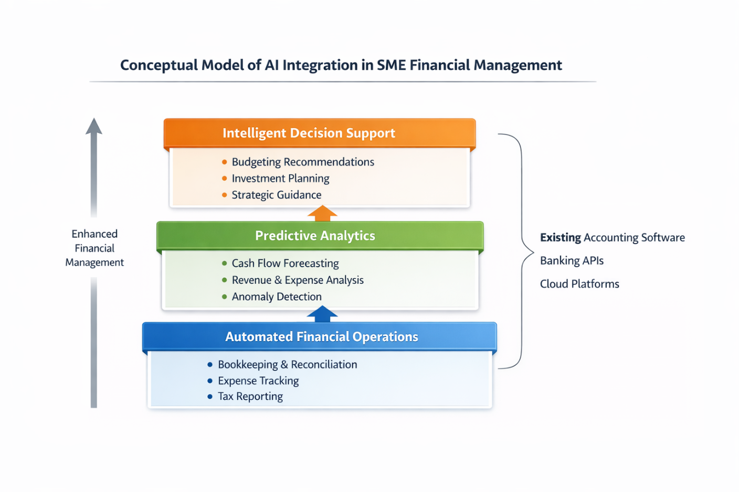
Figure 1 shows a three-layer system: Automated Financial Operations, Predictive Analytics, and Intelligent Decision Support. Arrows indicate data flow upward from operations to analytics to decision support, with lateral integration to accounting software, banking APIs, and cloud platforms.
3.1 Automated Financial Operations
- Transaction classification and reconciliation
- Expense tracking and invoice management
- Tax reporting and regulatory compliance support
3.2 Predictive Analytics
- Cash flow forecasting and scenario modeling
- Revenue and expense trend analysis
- Anomaly detection and financial risk identification
3.3 Intelligent Decision Support
- Budgeting and cost-optimization recommendations
- Investment planning insights
- Operational strategy guidance based on historical and real-time financial data
3.4 Integration and Accessibility
- Compatibility with accounting software and banking platforms
- User-friendly interfaces for non-technical SME staff
- Modular architecture allowing scalable deployment and customization

4. Implementation Considerations
Table 1. Key Considerations for AI Adoption in SMEs
Consideration | Description
Data Quality | Accurate, structured financial data is essential for AI performance.
Cost and Accessibility | AI solutions must be affordable and easy to implement for SMEs.
Trust and Interpretability | Recommendations should be transparent and understandable.
Cybersecurity | Sensitive financial data must be protected against breaches.
Regulatory Compliance | Systems must adhere to federal and state financial reporting standards.
Additional considerations include organizational readiness, technical infrastructure, and ongoing training to ensure effective AI adoption (Chen et al., 2020).

5. Potential Benefits
AI adoption in SME financial management can yield significant advantages:
- Operational Efficiency: Reduction of manual bookkeeping and reconciliation efforts.
- Enhanced Decision-Making: Predictive analytics and intelligent recommendations enable proactive financial strategies.
- Competitive Advantage: SMEs can respond faster to market trends and optimize resource allocation.
- Cost Savings: Lower dependence on external consultants and financial advisors.
- Risk Mitigation: Early identification of financial anomalies reduces potential losses.

6. Challenges and Limitations
- Technological Literacy: SME staff may lack expertise to interact with AI systems effectively.
- Initial Costs: Investment in software, training, and data preparation may be substantial.
- Data Privacy and Security: Handling sensitive financial information requires robust cybersecurity measures.
- Data Availability: AI models require sufficient historical financial data to ensure accuracy.
- Trust and Transparency: SMEs need interpretable AI recommendations to confidently make financial decisions.

7. Future Directions
Future research and development can explore:
- Industry-specific AI solutions tailored to SME financial needs
- Integration with real-time banking systems and accounting platforms
- Use of Natural Language Processing (NLP) for automated report interpretation
- AI-driven advisory services for micro and small enterprises
- Longitudinal studies assessing AI impact on SME financial performance and growth
Figure 2. Proposed AI-Driven SME Financial Workflow
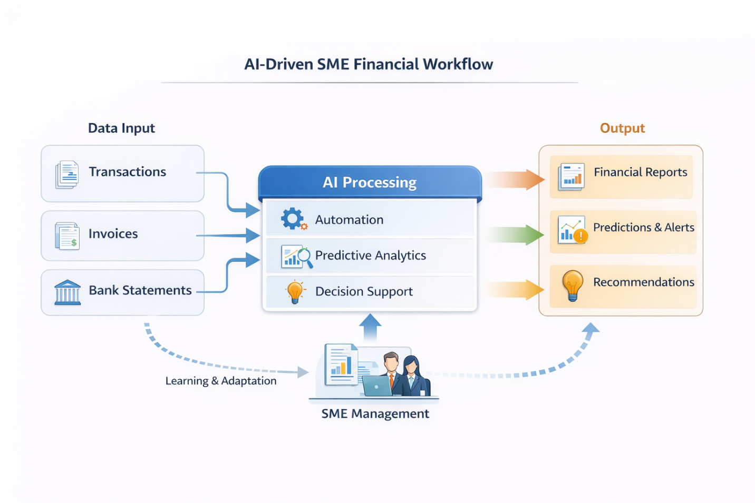

8. Conclusion
AI-powered tools have the potential to transform financial management for SMEs by automating repetitive tasks, providing predictive insights, and supporting strategic decision-making. Adoption of AI can improve operational efficiency, reduce errors, enhance decision-making, and strengthen SME competitiveness. As SMEs are critical to the U.S. economy, widespread implementation of AI in financial management can contribute to economic resilience and growth.

References
- Brynjolfsson, E., & McAfee, A. (2017). Machine, Platform, Crowd: Harnessing Our Digital Future. W. W. Norton & Company.
- Chen, J., Xu, H., & Zhang, Y. (2020). AI Adoption in SMEs: Barriers and Opportunities. Journal of Small Business Management, 58(3), 456–472.
- Davenport, T. H., & Ronanki, R. (2018). Artificial Intelligence for the Real World. Harvard Business Review.
- Gartner Research. (2020). AI in Small and Medium Enterprises: Opportunities and Challenges.
- U.S. Small Business Administration. (2021). Small Business Economic Impact Report.

